**Objective**

**MobileNets** is an efficient model for embedded vision applications. MobileNets are based on a streamlined architecture that uses depth-wise separable convolutions to build light weight deep neural networks. The model has a strong performance compared to other popular models on ImageNet classification. The model has a wide range of applications in object detection and finegrain classification.

Our Goal: Create an efficient, scalable Pneumonia detection system using MobileNets neural network.

**Data**

Chest X-Ray Images (Pneumonia): a collection of expert-physician-evaluated 5,863 images of patient chest x-rays with 2 categories (Pneumonia/Normal).

The dataset is organized into 3 folders (train, test, val) and contains subfolders for each image category (Pneumonia/Normal).

**Evaluation Metrics**

Adam Optimization:

* We use Adam as an optimization algorithm instead of the classical stochastic gradient descent procedure to update network weights.
* The method computes individual adaptive learning rates for different parameters from estimates of first and second moments of the gradients.

Categorical Cross Entropy:

* Loss Function will be categorical cross entropy
* Cross-entropy loss, or log loss, measures the performance of a classification model whose output is a probability value between 0 and 1.

Accuracy:

* Evaluation metric will be accuracy.
* Accuracy is a fraction of prediction our model got right.

**Models**

Depth-wise Separable Convolutions:

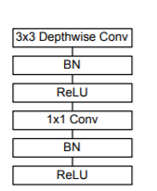

MobileNet Body Architecture:

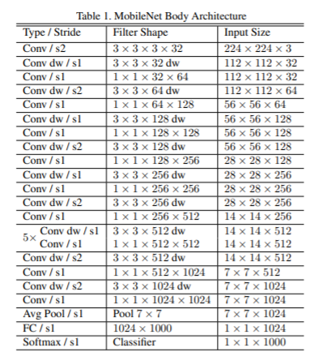

* The MobileNet model is based on depthwise separable convolutions which is a form of factorized convolutions which factorize a standard convolution into a depthwise convolution and a 1×1 convolution called a pointwise convolution.
* MobileNet models were trained in TensorFlow using RMSprop with asynchronous gradient descent.
* Parameter α called width multiplier, to reduce the computational cost of a neural network.

**Results and Discussion**

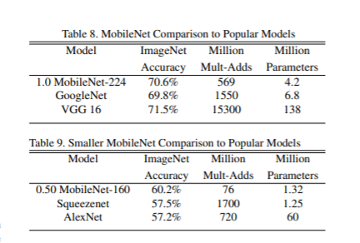

* MobileNet when compared to the original GoogleNet and VGG16, MobileNet is nearly as accurate as VGG16 while being 32 times smaller and 27 times less compute intensive. It is more accurate than GoogleNet while being smaller and more than 2.5 times less computation.
* Reduced MobileNet is 4% better than AlexNet while being 45× smaller and 9.4× less compute than AlexNet. It is also 4% better than Squeezenet at about the same size and 22× less computation.

**Conclusion**

* We dabbled upon a new model architecture called MobileNets based on depthwise separable convolutions.
* We compared different MobileNets to popular models demonstrating superior size, speed and accuracy characteristics.
* We demonstrated effectiveness of MobileNet when applied to a Pneumonia Detection.

**References**

1] *MobileNets: Efficient Convolutional Neural Networks for Mobile Vision Applications* <https://arxiv.org/abs/1704.04861>

2] *Chest X-Ray Images (Pneumonia)*  <http://www.cell.com/cell/fulltext/S0092-8674(18)30154-5>